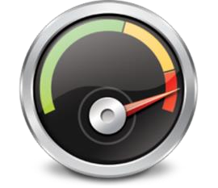

Quick Start Guide to Install & Configure

Accelerator for .NET

For Use with Microsoft SQL Server or IBM i DB2 Databases

Version V4 R1 M0

5/14/2024

# *End User License Agreement*

IMPORTANT - PLEASE READ CAREFULLY: This End User License Agreement (this "Agreement") is a legal agreement between you (either an individual or a single entity) and Surround Technologies, LLC (Surround) for the Surround Accelerator products, which includes computer software and associated media, printed materials and electronic or "on-line" documentation (Software). By installing, copying, or otherwise using the Software, you agree to be bound by the terms of this Agreement. If you do not accept the terms of this Agreement, promptly return the unused Software to the place in which you obtained it for a full refund.

1. GRANT OF LICENSE. (a) Surround Technologies, LLC, grants you a nonexclusive license to use the Software, subject to the following:

Except as stated below, you may install the Software on only one computer. If the Software can be used from any computer other than the computer on which it is installed (whether because the computer on which it is installed is part of a network or for any other reason), you must license a copy of the Software for each computer from which the Software may be used. For example, if there are ten computers that have access to the Software on your network, then you must license ten copies of the Software solely for use on that network.

If you remotely install or otherwise install the Software on another user's computer for file transfers or other remote operations, you must delete the Software from the other computer immediately after you complete your transfer or remote operation.

You may make a reasonable number of back-up copies of the Software. The back-up copies may be used only to replace an unusable copy of the Software. You must destroy any copies of the Software that are replaced by a back-up copy. Back-up copies must include all proprietary rights notices appearing on the original and must remain in your possession or control.

Except as specifically permitted in this Agreement, you may not (i) copy the Software, (ii) modify the Software or separate out any of its components for use with other software (except to the extent contemplated in the enclosed user documentation) (iii) use the Software to provide time sharing, service bureau or similar services, or (iv) decompile, disassemble, or otherwise reverse engineer the Software.

You may not allow anyone to do anything that this Agreement prohibits you from doing.

(b) You understand that the Software is licensed to you and not sold. Surround retains title to all copies of the Software.

2. LIMITED WARRANTIES AND DISCLAIMER OF IMPLIED WARRANTIES. (a) Surround warrants that, for ninety (90) days after you obtain the Software (the "Warranty Period"), (i) the Software will operate as stated in the enclosed user documentation, and (ii) the disk or other media on which the Software may be provided will be free of defects in material or workmanship. This limited warranty does not cover anything caused by accident or abuse or by use of the Software other than for its reasonably intended purposes and as recommended in the accompanying user documentation. Also, Surround does not warrant that the operation of the Software will be uninterrupted or error free. This warranty gives you specific legal rights, and you may also have other rights which vary from state to state.

(b) Except as stated in Section 2(a), Surround does not make any warranties. In particular, Surround disclaims all implied warranties, including the implied warranties of merchantability, fitness for a particular purpose, and noninfringement. The duration of any implied warranty that is not effectively disclaimed will be limited to the 90-day Warranty Period. Some states do not apply limitations on how long an implied warranty lasts, so the above limitation may not apply to you.

1. EXCLUSIVE REMEDIES. (a) If, during the Warranty Period, you report any breach of warranty to Surround and Surround is reasonably able to verify that breach, Surround or its agent will, at its option, either (i) correct the Software or replace any defective media, (ii) help you work around or avoid the problem, or (iii) allow you to return the Software, all accompanying documentation, and all other accompanying written materials in the original packaging for a full refund. If you return the Software for a refund, you may not retain or use the Software, and you must immediately destroy all back-up copies and any other copies of the Software in your possession or control.

During the Warranty Period, you may report breaches of warranty over the phone by calling 973.743.1277 or by letter addressed to 9197 Estero River Circle, Estero, FL 33928, Attention: Customer Service. You must describe the breach in detail and include a phone number or address at which you can be reached during normal business hours. Surround will respond within a reasonable time to any reported breach. You must pay all costs of shipping any Software or other materials. Any corrected or replaced software that you obtain under this Agreement will be considered part of the Software licensed under this Agreement and will be covered by warranty only for any time remaining in the original Warranty Period.

The remedies stated in this Section 3 are your only rights or remedies, and will be Surround's only liability or obligation, for any breach by Surround of any warranty.

1. PROPRIETARY RIGHTS. Subject to this Agreement, Surround and its licensors retain all copyrights, trade secret rights, patents, trademarks, and any other proprietary rights covering or relating to the Software. You acknowledge that the Software includes or incorporates proprietary and confidential information belonging to Surround and/or its licensors. All rights not expressly granted by Surround in this Agreement are reserved.
2. EXCLUSION OF CONSEQUENTIAL DAMAGES; LIMITATION OF LIABILITY. Neither Surround nor its affiliates nor its licensors will be liable for any special, incidental, consequential or exemplary damages, including without limitation damages for loss of use, lost profits or loss of data or information of any kind, arising out of or in connection with the Software or its use or this Agreement, even if Surround Technologies or its affiliates or its licensor have been advised of the possibility of such damages. In no event will Surround's or its affiliates' or its licensors' liability for any claim relating to the Software or its use or this Agreement, whether in contract, tort or any other theory of liability, exceed the license fee paid by you. Some states do not allow the exclusion or limitation of incidental or consequential damages, so the above limitation or exclusion may not apply to you.
3. CAUTIONS REGARDING DATA. The Software contains tools to be used in transmitting, searching, and retrieving data in various forms as described in the documentation. You assume the entire responsibility for determining the legality of any transmission or copying you may engage in and for protecting yourself, your business, family, and associates from any offensive or inaccurate data, information, or material you may choose to receive or allow to be transmitted to you. Without limiting the foregoing, if you access data from sources including, but not limited to, bulletin boards, data services, or the Internet, your access is provided only on an "as is" and "as available" basis. Surround does not grant any warranty with respect to, or assume any responsibility for any consequences whatsoever suffered by any person as a result of, your access or use of the Internet including, without limitation, access to or resulting in false, incomplete or unreliable data, sexually explicit or violent material, defamatory or derogatory content, computer viruses, or corrupted data.
4. LIMITS ON YOUR RIGHT TO TRANSFER. You may not sublicense, rent, lease, lend, sell, grant a security interest in, or otherwise transfer the Software or any rights under this Agreement, except that you may transfer your copy of the Software if: (i) you transfer to the same person all copies of the Software and of any accompanying documentation in your possession or control, (ii) that person agrees in writing to assume all of your obligations under and otherwise to be bound by this Agreement, and (iii) you notify Surround at the address or phone number specified below of the transfer of the Software, including the name, address and phone number of the new owner of the Software and the serial number of the Software. Your rights under this Section 7 only apply to incidental transfers. No right is granted to transfer or in any way distribute multiple copies of the Software in connection with a trade or business (whether as a value-added reseller, OEM, distributor, systems integrator, or otherwise).
5. EXPORT. You acknowledge that the Software is subject to United States export control laws, including the export administration regulations. You will not export, re-export or divert the Software in contravention of those laws.
6. TERMINATION. Surround may terminate this Agreement if you violate it. You must destroy all copies of the Software in your possession or control promptly upon termination. Upon Surround's request, you must certify in writing that you have complied with your obligations under this Section 9 and otherwise under this Agreement. Termination by Surround will not limit any of its other rights or remedies under this Agreement or at law or in equity. Any provision of this Agreement that by its sense and context is intended to survive termination of this Agreement will survive termination.
7. SEVERABILITY. If any provision of this Agreement is illegal or unenforceable under applicable law, the remaining provisions of this Agreement will remain valid and fully enforceable. If any provision is in part enforceable and in part unenforceable, it will be enforced to the extent permitted under applicable law.
8. U.S. GOVERNMENT RESTRICTED RIGHTS. If this product is licensed by a DoD agency, such agency's rights in this product are governed by the restrictions in the Technical Data -- Commercial Items clause at DFARS 252.227-7015 and DFARS 227.7202, or any successor regulation. If this product is licensed by any other agency or instrumentality of the United States of America, use, duplication and disclosure are subject to restriction as set forth in subparagraphs (a) - (d) of the rights in Technical Data and Computer Software clause at FAR 52.227-19 or any successor regulation, or as set forth in the particular department or agency regulations or rules which provide Surround Technologies, LLC or its licensors protection equivalent to or greater than that clause.
9. GOVERNING LAW. This Agreement is governed by USA Florida law.
10. ENTIRE AGREEMENT. This Agreement, together with any special rights or promotions provided in writing with your copy of the Software, is the entire agreement between you and Surround relating to the Software. It supersedes any prior or contemporaneous oral or written communication relating to the Software.

Should you have any questions concerning this Agreement, or if you desire to contact Surround Technologies, LLC for any reason, please write: 9197 Estero River Circle, Estero, FL 33928, Attention: Customer Service. Alternatively, you may:

Call Surround at (973) 743-1277,

Email Surround at info@surroundtech.com

Except as stated in Section 2(a), Surround does not make any warranties. In particular. Surround disclaims all implied warranties, including the implied warranties of merchantability, fitness for a particular purpose, and noninfringement. The duration of any implied warranty that is not effectively disclaimed will be limited to the 90-day Warranty Period. Some states do not apply limitations on how long an implied warranty lasts, so the above limitation may not apply to you.

# *Copyright Information*

Copyright © 1998-2024 Surround Technologies, LLC All rights reserved worldwide.

**NOTICE:**

This documentation and the Software associated with this document are protected by copyright. You may not copy, modify, translate, or reproduce this document or any part of this document in any form without prior written permission from Surround Technologies, LLC

The software associated with this document is governed by a license agreement and may be used only under strict adherence to the terms of that license agreement.

Microsoft, Windows, .NET, Active X, Visual Studio, Windows Presentation Foundation, and Microsoft Office including Word, Excel are registered trademarks of Microsoft Corporation.

IBM, IBM i, and IBM i .NET Data Provider are registered trademarks of IBM.

Accelerator™ Development Solutions are developed by:

Surround Technologies, LLC™

9197 Estero River Circle

Estero, FL 33928

Copyright © 1998-2024 Surround Technologies, LLC All rights reserved worldwide.

**Table of Contents**

*End User License Agreement* 2

*Copyright Information* 3

**1.** **Overview** 5

**2.** **Prerequisites** 5

**2.1 Visual Studio** 5

**2.2 Access to a Database** 5

**2.3 Microsoft SQL Server or SQL Server Express Database** 5

**2.3.1 Installing Microsoft SQL Server or SQL Server Database** 5

**2.3.2 EasyBuy Demonstration Database (Optional)** 6

**2.3.3 Configuring Microsoft SQL Server for EasyBuy Database** 6

**2.4 IBM I DB2 Database Server** 8

**2.4.1 Installing and configuring the IBM I .NET Data Provider** 8

**2.4.2 EasyBuy Demonstration Database (Optional)** 10

**3.** **Accelerator for .NET** 11

**3.1 Installation** 11

**3.2 Configuration** 13

**3.3 Generation Wizard Plugin** 14

**3.4 Accelerator Generation Standards** 15

# **Overview**

Surround’s Accelerator Development Solutions are a complete suite of Frameworks and Tools that empower developers to develop Faster, with better results, and More functionality to deliver the software customers, employees, business partners, and vendors will love. The resulting systems allow for the seamless integration of .NET applications with various application and database servers to enhance user experience and productivity to drive greater growth and profit for the business.

# **Prerequisites**

## **2.1 Visual Studio**

Before you begin, you will need to have **Visual Studio 2012 or higher** installed on your system. Visual Studio 2022 or higher is recommended.

If you require a copy of Visual Studio, the Visual Studio Community Edition is free for individual developers, open-source projects, academic research, education, and small professional teams. Simply download the installer and follow the on-screen instructions for a complete installation.

**Visual Studio Product Page:**<https://visualstudio.microsoft.com/>

**VS 2019 Community Edition:**<https://visualstudio.microsoft.com/vs/community/>

**2.2 Access to a Database**  
Accelerator is used to quickly develop applications using existing databases. For evaluation purposes you can use your own or download Surround’s EasyBuy Demonstration Database.

This Quick Start Guide provides instructions for Microsoft SQL Server and IBM i DB2 Database servers. Accelerator supports development with many other databases as well. Please contact us at support@surroundtech.com if you have questions about other databases.

## **2.3 Microsoft SQL Server or SQL Server Express Database**

If you plan to use Accelerator to create an application that accesses a Microsoft SQL Server or SQL Server Express database, you will need network access to an installation of **SQL Server 2008 R2 or higher**. SQL Server 2019 or higher is recommended

### **2.3.1 Installing Microsoft SQL Server or SQL Server Database**

If you require a copy of Microsoft SQL Server database to evaluate Accelerator, we recommend installing Microsoft SQL Server Express locally on your development PC.

**SQL Server Product Page:**<https://www.microsoft.com/en-us/sql-server/>

**SQL Server Downloads:**<https://www.microsoft.com/en-us/sql-server/sql-server-downloads>

### **2.3.2 EasyBuy Demonstration Database (Optional)**

The following files are optional downloads if you wish to utilize Surround Technologies’ free EasyBuy Cycles demo database which will allow you to follow along with the demo videos and tutorials. EasyBuy provides everything you need to experience the benefits of generating systems with Accelerator.

**Download Link:**<http://services.surroundtech.com/downloads/Products/A4DN/EasyBuyMSSQLScripts.zip>

### **2.3.3 Configuring Microsoft SQL Server for EasyBuy Database**

If using the Surround Technologies EasyBuy Database, you will need to create a user with the proper authorizations for creating and maintaining your database, as well as the initial sample database itself.

Open Microsoft SQL Server Management Studio and connect to your Database Engine. Right click on your Database Server in the Object Explorer and select Properties. Click on the Security page and make sure SQL Server and Windows Authentication mode are selected. Press OK.

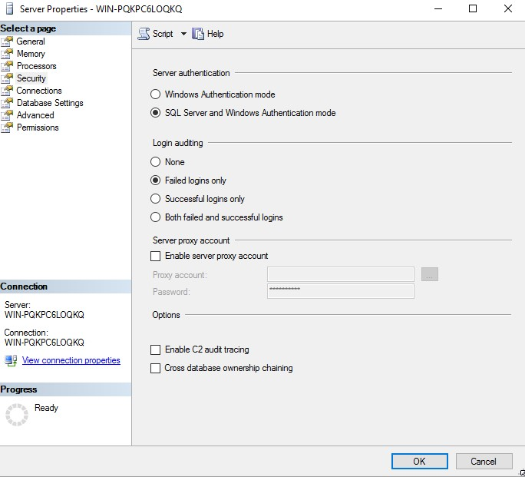

Next, create a new database by right clicking the Databases folder in the Object Explorer and selecting “New Database”. Name your new database “EasyBuyDev”. Press OK to save the database.

Next, expand the Security folder of your database connection, right-click on Logins and select New Login. Select a Login Name, select “SQL Server authentication” and specify a password. You may want to uncheck “User must change password at next login”.

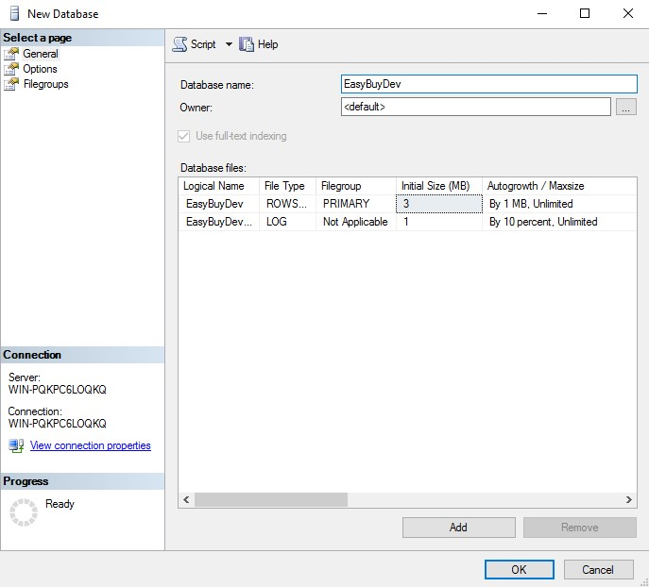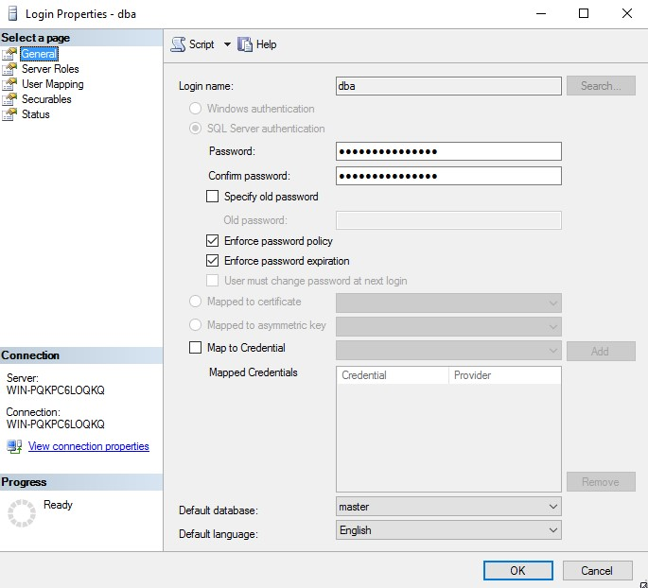

Next, select the Server Roles page and grant the user “public” and “sysadmin” security privileges.

Lastly, select the Status page and confirm that the user has been Granted Permission to connect to the database engine, and that the login is Enabled. Click OK to finish creating the user.

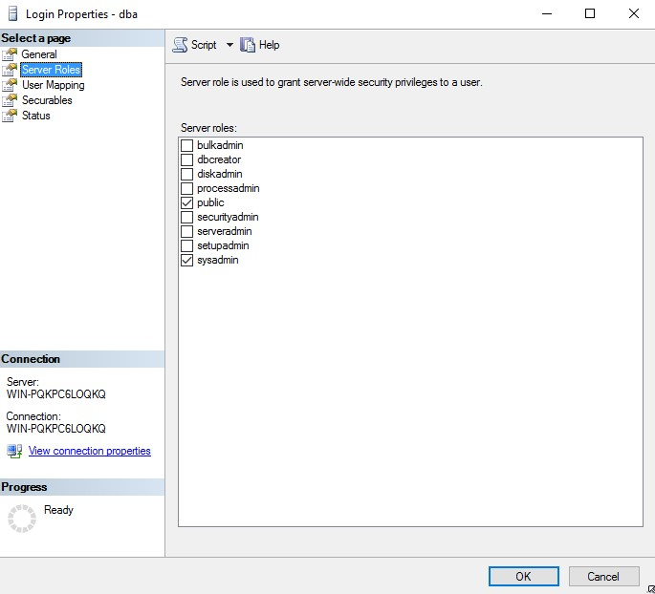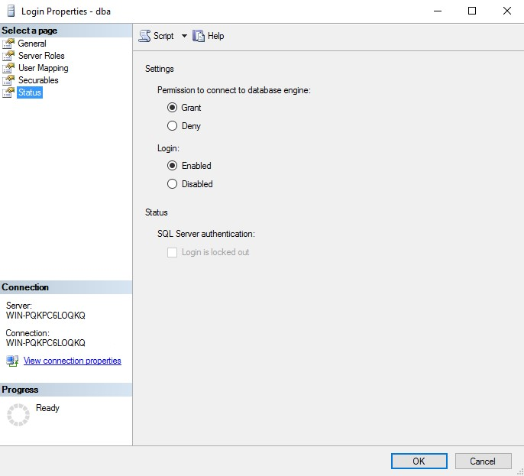

The Microsoft SQL Server Database is now configured for use with Accelerator for .NET.

Now that the database and user for the demo have been created, we just need to configure the EasyBuyDev database prior to the installation of the free trial software if you plan to use the provided Free Demo EasyBuy system. We’ve gone ahead and wrote some scripts to make this simple and easy. Locate the zip file named “EasyBuyMSSQLScripts” downloaded in section: EasyBuy Demonstration Database (Optional).

When you unzip this file, you will see the EasyBuy Schema and 5 other scripts which contain the data we will use to configure the database for use with the EasyBuy demo system. In SQL server Management Studio, you will need to run these scripts **in the following sequence**:

1. EasyBuyDev_Schema.sql EasyBuy Database Schem
2. EasyBuyDev_YD1C.sql Customer Data
3. EasyBuyDev_YD1O.sql Order Data
4. EasyBuyDev_YD1P.sql Product Data
5. EasyBuyDev_YD1S.sql Shipping Address Data
6. EasyBuyDev_YD1I.sql Order Item Data

Simply open each file by double clicking it and running in SQL Management Studio one at a time and select “Execute” from the SQL Management Studio toolbar. Longer scripts may take some time to complete, progress can be tracked at the bottom of the Microsoft SQL Server Management Studio screen.

## **2.4 IBM I DB2 Database Server**

If you plan to use Accelerator to create an application that accesses an IBM Power Systems IBM i DB2 database, you will need network access to a system with **IBM i OS V6.1 or later**. IBM i OS V7.3 or higher is recommended.

**IBM i Product Page:**<https://www.ibm.com/it-infrastructure/power/os/ibm-i>

### **2.4.1 Installing and configuring the IBM I .NET Data Provider**

There are many ways of accessing the IBM i integrated DB2 database. The following provides instructions for using the IBM i .NET Data Provider, a free solution included with IBM i Access Client Solutions. Please contact us at support@surroundtech.com if you have questions about DB2 Connect or other ways to access.

You will need an IBM ID and Password to access the downloads.

**IBM i Access Client Solutions Information:** <https://www.ibm.com/support/pages/ibm-i-access-client-solutions>

**IBM i Access Client Solutions Download Page:**<https://www.ibm.com/resources/mrs/assets?source=swg-ia>

**IBM i Access Client Solutions Download:** [https://iwm.dhe.ibm.com/sdfdl/v2/regs2/sharee2/iacsjava/v1r1/Xa.2/Xb.Fjx4e5cja3gCAXSAOEU3QUtuUdWwMC0eBwGtxPCfr8k/Xc.iacsjava/v1r1/IBMiAccess_v1r1.zip/Xd./Xf.lPr.D1vk/Xg.11751639/Xi.swgia/XY.regsrvs/XZ.gZxL2TMd7GPx8BJC_R_eJ9SvSmONHEsc/IBMiAccess_v1r1.zip](https://iwm.dhe.ibm.com/sdfdl/v2/regs2/sharee2/iacs-java/v1r1/Xa.2/Xb.Fjx4e5cja3gCAXSAOEU3QUtuUdWwMC0eBwGtxPCfr8k/Xc.iacs-java/v1r1/IBMiAccess_v1r1.zip/Xd./Xf.lPr.D1vk/Xg.11751639/Xi.swg-ia/XY.regsrvs/XZ.gZxL2TMd7GPx8BJC_R_eJ9SvSmONHEsc/IBMiAccess_v1r1.zip)

The free IBM i ACS .NET Data Provider gets installed through the “IBM i Access Client Solutions - Windows Application Package”.

**Windows Application Package Download:** [https://iwm.dhe.ibm.com/sdfdl/v2/regs2/sharee2/iacsjava/v1r1/Xa.2/Xb.Fjx4e5cja3gCAXSAOEU3QUtuUdWwMC0eBwGtxPmZYWw/Xc.iacsjava/v1r1/IBMiAccess_v1r1_WindowsAP_English.zip/Xd./Xf.lPr.D1vk/Xg.11751639/Xi.swgia/XY.regsrvs/XZ.gU663PwJUeK72n3fM-vNnTn3UFlncm3O/IBMiAccess_v1r1_WindowsAP_English.zip](https://iwm.dhe.ibm.com/sdfdl/v2/regs2/sharee2/iacs-java/v1r1/Xa.2/Xb.Fjx4e5cja3gCAXSAOEU3QUtuUdWwMC0eBwGtxPmZYWw/Xc.iacs-java/v1r1/IBMiAccess_v1r1_WindowsAP_English.zip/Xd./Xf.lPr.D1vk/Xg.11751639/Xi.swg-ia/XY.regsrvs/XZ.gU663PwJUeK72n3fM-vNnTn3UFlncm3O/IBMiAccess_v1r1_WindowsAP_English.zip)

**Install IBM i Access Client Solutions –** This is a Java Application. You must have Java installed for it to work and the Installation itself is a bit different than typical windows installations. You must unzip it and go to the **Windows_Application** folder, right click on **install_acs_64_allusers.js** and open it using **Microsoft Windows Based Script Host**.

**Important:** If you have the previous IBM I Client Access version installed, it **MUST** be uninstalled first.

**Install ACS Windows Application Package –** You must unzip the downloaded file, go to the Image64a folder, and run setup.exe.

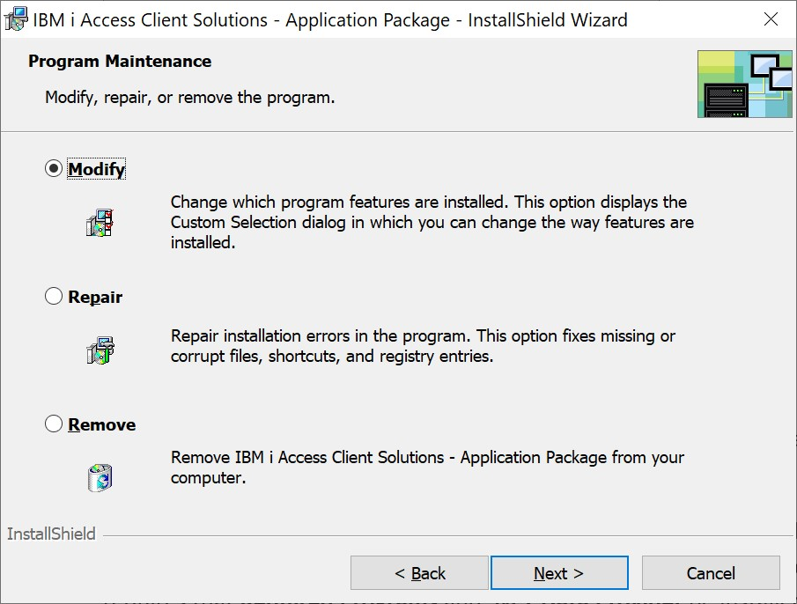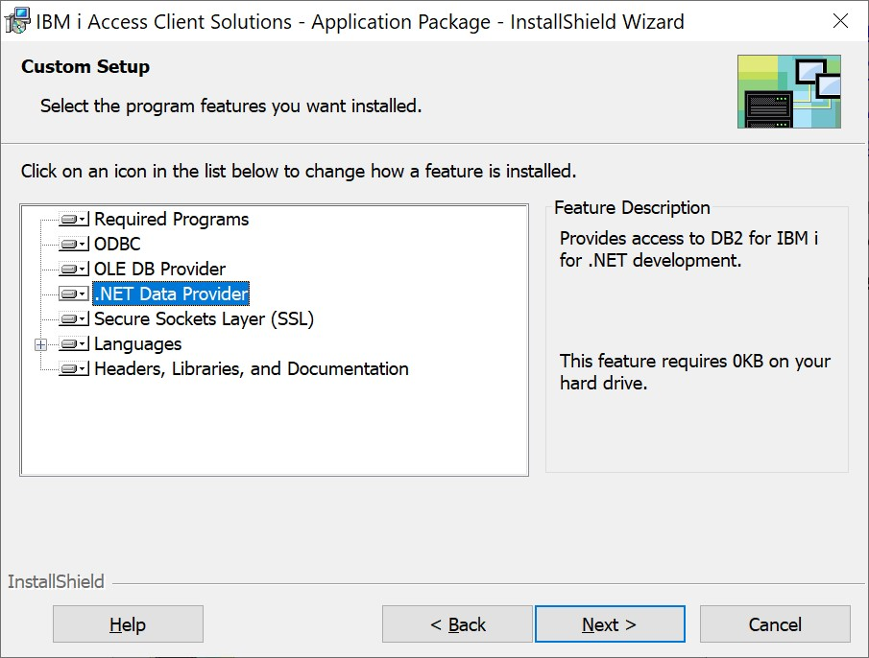

Make sure the .NET Data Provider is selected and click the **Next** button. The Accelerator only requires that **Required Programs** and **.NET Data Provider** be installed. It is your preference if you wish to install the other options. Click Next to finalize the installation.

Click **Install** to complete the installation.

### **2.4.2 EasyBuy Demonstration Database (Optional)**

The following files are optional downloads if you wish to utilize Surround Technologies’ free EasyBuy Cycles demo database which will allow you to follow along with the demo videos and tutorials. EasyBuy provides everything you need to experience the benefits of generating systems with Accelerator.

**Download Link:**<http://services.surroundtech.com/downloads/Products/A4DN/EasyBuyDB2SaveFile.zip>

To make setup and configuration simpler, we have created a save file that will take the heavy work out of any configuration. Simply download the zipped save file from: <http://services.surroundtech.com/downloads/Products/A4DN/EasyBuyDB2SaveFile.zip>

Unzip the save file named easybuydev.savf.

On your IBM i, use the following command to create a new save file:

*CRTSAVF FILE(EASYBUYDEV) TEXT('Easy Buy Demo Save File’)*

FTP the easybuydev.savf file from your PC to your IBM i by opening a command prompt and issuing the following commands:

*cd <the folder location of the file easybuydev.savf.>*

*ftp <Your IBM i IP Address> <IBM i User ID> <IBM i Password> bin*

*Put easybuydev.savf easybuydev*

On your IBM i, use the following command to restore the library in the save file:

*RSTLIB SAVLIB(EASYBUYDEV) DEV(*SAVF) SAVF(EASYBUYDEV)*

The library EASYBUYDEV will now have the 5 EasyBuy files that are used in the Accelerator Generation Demo.

# **Accelerator for .NET**

## **3.1 Installation**

Locate the “Accelerator Environment Provisioned” email you received upon registering for the trial. Download the Accelerator for .NET that best suits your system, 32-bit for x86 systems or 64-bit for x64 systems. You will also need to download the included Generation Standards Zip File.

Extract the contents of the Generation Standards zip file, and then place the Accelerator for .NET folder contained in it within your Documents folder. It should look like the following:

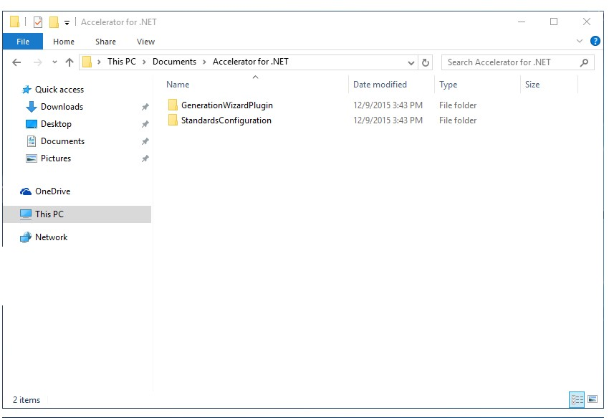

Run the Accelerator Setup installer to begin the installation of Accelerator for .NET. The on-screen instructions will quickly guide you through the installation process including where to save your application files. If you are prompted with any Windows security warnings, allow access to the setup application to continue the install.

Windows Security prompts may be displayed. Grant Permission to proceed with installation.

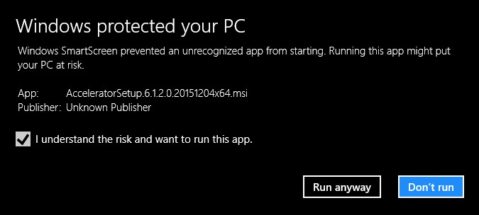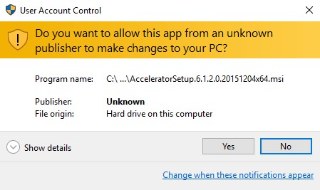

Once the installation is complete, run the Accelerator launchpad from your desktop by double clicking the Accelerator icon created during the installation process.

## **3.2 Configuration**

Before you can begin creating your applications, you’ll need to configure the Accelerator to connect to the database you created earlier. To do this, run the Accelerator Launchpad from the Desktop and click Configuration from the Accelerator’s Launch Pad window.

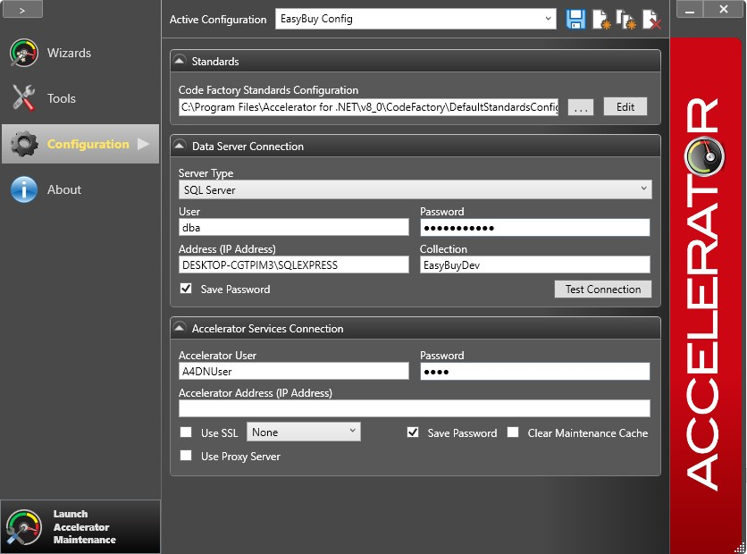

**Accelerator Generation Standards:** To make the configuration process simpler, your Generation Standards zip file contains preset standards configurations to get you started. Under the standards area, select the browse button “…” and navigate to Documents > Accelerator for .NET > Standards Configuration > EasyBuy Folder. For Microsoft SQL databases select the StandardsConfiguration_MSSQL.xml file. For IBM users a DB2 standards xml file has been provided as well.

**Data Server Connection:** Next, in the Data Server Connection area, select your server type, ie: MS SQL Server. Enter the user and password for your Server. If the database is on your local machine use the instance name, typically the topmost level of the tree in SQL Server Management Studio, for the Address. If your server is located on a network, use the IP address of that server. Be sure to enter the Database you wish to use, ie: EasyBuyDev, and click Test Connection to guarantee the specified location and credentials have the proper authorizations and can successfully connect to your SQL Server database.

**Accelerator Services Connection:** Lastly, enter your Accelerator username and password, found at the bottom of the “Accelerator Environment Provisioned” email. You will also need the Accelerator Address for connecting to your own personally provisioned environment.

Now that you’ve installed and configured the Accelerator, you’re ready to begin generating systems faster than before, with better results and more functionality. Thank you for choosing the Accelerator for .NET, and we hope you enjoy developing smarter.

## **3.3 Generation Wizard Plugin**

Some users may require rebuilding the Generation Tool prior to generation. To do this, navigate to your Documents > Accelerator for .NET > GenerationWizardPlugin folder and open the GenerationWizardPlugin.sln Solution using your copy of Visual Studio 2019. Right click on the GenerationWizardPlugin project in the Solution Explorer panel and select “Rebuild Solution”. Once the solution is rebuilt, simply exit Visual Studio. The Plugin is now ready to be used with the Generation Wizards.

## **3.4 Accelerator Generation Standards**

The Accelerator allows you to provide a plugin that tailors how code is generated based on your standards. If you choose to generate using our EasyBuy Database, it is recommended that you download and use the Accelerator Generation Standards.

This **AcceleratorGenerationStandards.zip** download is specific to each Accelerator version and is provided in your Accelerator Environment Provisioned email.